Business Intelligence Case Study: Flying Whale Airline

Objective of your analysis:

The objective is to utilize Power BI for visualizing Flying Whale Airline's data to enhance operational efficiency and customer satisfaction, while analyzing flight operations, customer behavior, cancellation trends, and rewards point’s redemption, including those redeemed by customers with their companions. Through this analysis, the project aims to identify opportunities for improvement, optimize revenue, and make data-driven decisions for strategic growth in the aviation industry.

Dataset overview:

1. **Customer Flight Activity:**

• Loyalty Number: A unique identifier for each customer's loyalty account.

• Year and Month: Period details for analysis.

• Flights Booked: Number of flights booked by the member during the period.

• Flights with Companions: Number of flights booked with additional passengers.

• Total Flights: Combined total of Flights Booked and Flights with Companions.

• Distance: Flight distance traveled in kilometers during the period.

• Points Accumulated: Loyalty points earned in the period.

• Points Redeemed: Loyalty points redeemed during the period.

• Dollar Cost Points Redeemed: Dollar equivalent for points redeemed in Canadian Dollars (CDN).

1. **Customer Loyalty History:**

• Loyalty Number: A unique identifier for each customer's loyalty account.

• Demographics: Country, Province, City, Postal Code, Gender, Education, Salary, Marital Status.

• Loyalty Card: Current loyalty card status

• Customer Lifetime Value (CLV): Total invoice value for all flights ever booked by the member.

• Enrollment Details: Enrollment Type (Standard / 2018 Promotion), Enrollment Year, Enrollment Month.

• Cancellation Details: Cancellation Year and Month if applicable.

Steps Taken:

1. **Data Cleaning:**

* Removed duplicates and cleaned the collected data to ensure accuracy and consistency.

1. **Setting Relationships:**

* Established correct relationships between tables to facilitate data integration and analysis.

1. **Creating New Tables:**

* Generated new tables to organize and structure the data effectively for analysis and visualization.

1. **Generating New Columns using DAX Queries:**

* Utilized Data Analysis Expressions (DAX) queries to create new columns based on calculated metrics or derived variables, enhancing the dataset's analytical capabilities.

1. **Measures Creation:**

* Developed measures using DAX to calculate aggregated values, key performance indicators (KPIs), and other metrics for analysis and reporting.

1. **Calculated Columns:**

* Created calculated columns to derive additional insights or perform calculations based on existing data, enriching the dataset with actionable information.

Visualization Techniques:

1. **Vertical and Horizontal Bar Charts**:

* Visualized categorical data such as flight routes, customer segments, or cancellation reasons, showcasing comparisons and trends effectively.

1. **Pie Charts and Hollow Pie Charts:**

* Represented proportions of total values, such as revenue distribution by fare class or customer satisfaction levels, offering clear insights into percentages and proportions.

1. **Map Visualizations:**

* Mapped geographical data to visualize flight routes, customer locations, or performance metrics across different regions, providing spatial insights and highlighting areas of interest.

1. **Narratives:**

* Incorporated narratives or textual insights alongside visualizations to provide context, explanations, and actionable recommendations based on the data analysis, enhancing the understanding of key findings.

1. **Line Charts:**

* Illustrated trends over time, such as flight delays, revenue growth, or customer satisfaction scores, facilitating the identification of patterns and temporal variations.

Dash Board:

**Flight Activity Analysis:**

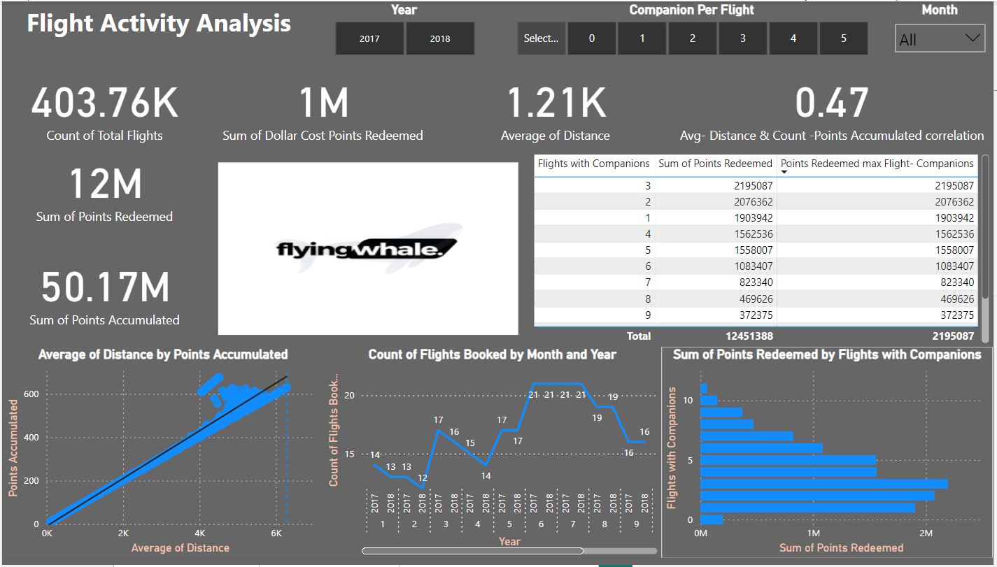

**Loyalty Segmentation:**

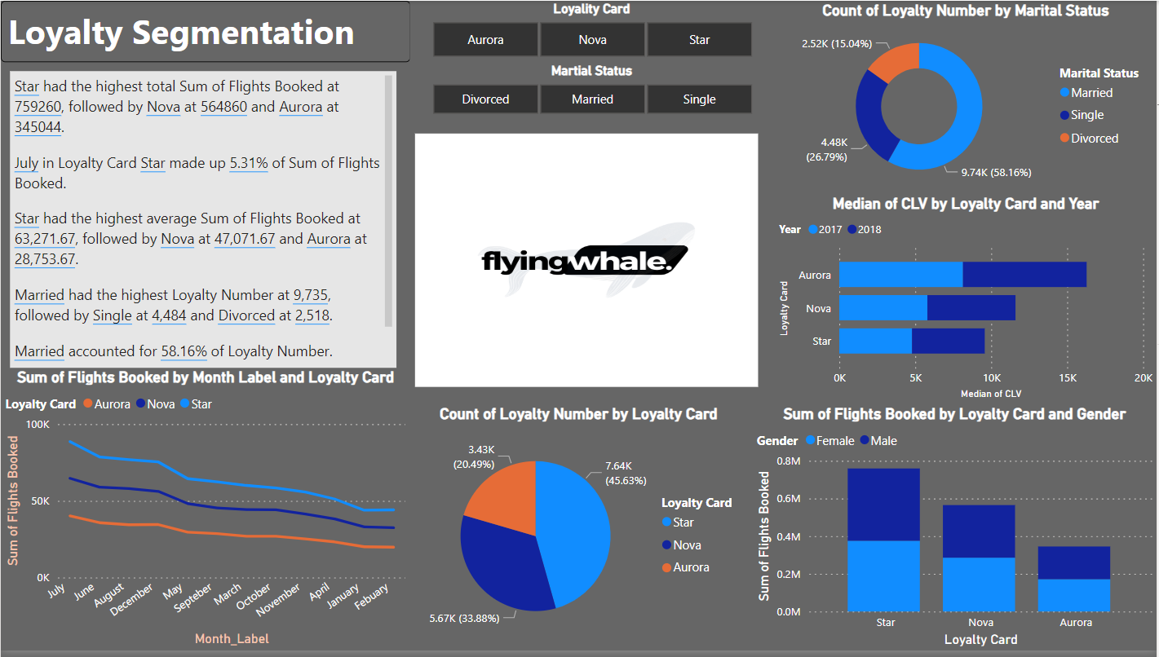

**Enrollment and Cancellation Trends:**

